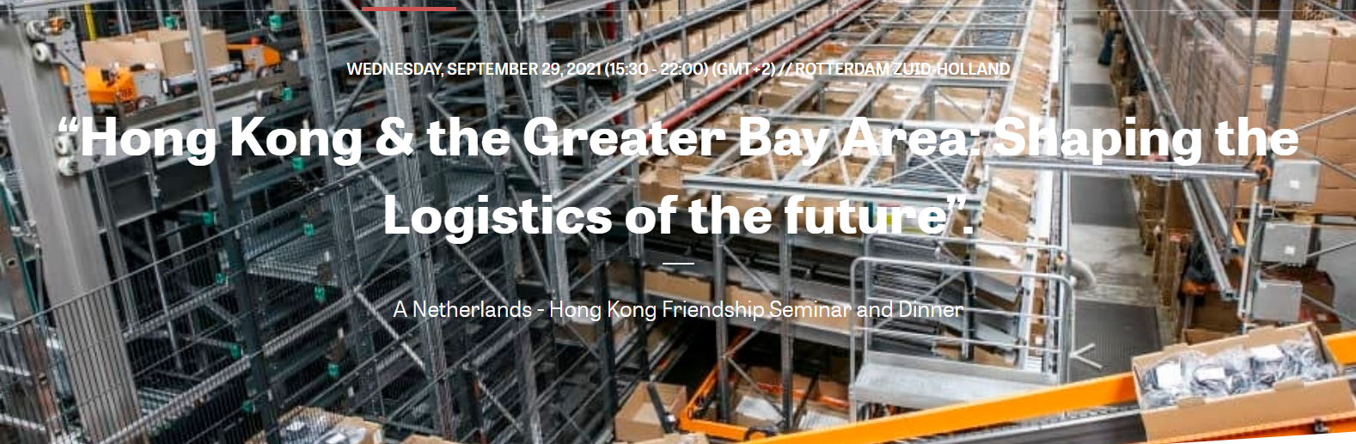

Introduction video by Tom van Dillen
Managing Partner Beijing Office at Greenkern Group
Place cursor here and click for link

